**ASSESMENT -2**

**NAME : MUHAMMED ALI MASOOD**

SELECT CategoryName, Description

FROM Categories

ORDER BY CategoryName ASC;

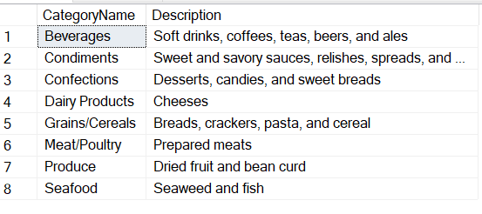

SELECT ContactName, CompanyName, ContactTitle, Phone

FROM Customers

ORDER BY Phone ;

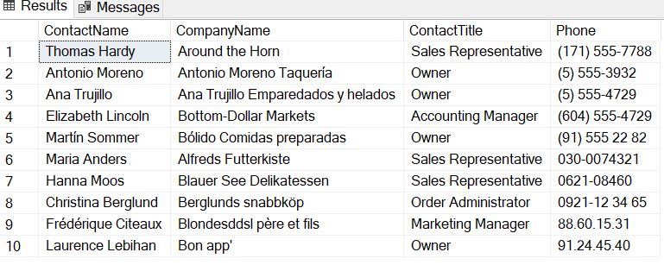

SELECT FirstName, LastName, HireDate

FROM Employees

ORDER BY HireDate;

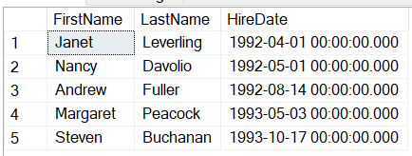

SELECT OrderID, OrderDate, ShippedDate, CustomerID, Freight

FROM Orders

ORDER BY Freight DESC;

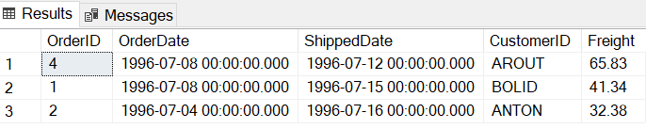

SELECT CompanyName, Fax, Phone, HomePage, Country

FROM Suppliers

ORDER BY Country DESC, CompanyName ASC ;

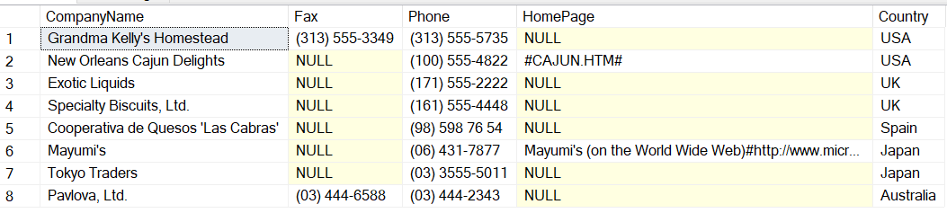

SELECT CompanyName, ContactName

FROM Customers

WHERE City = 'Buenos Aires';

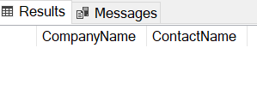

SELECT ProductName, UnitPrice, QuantityPerUnit

FROM Products

WHERE UnitsInStock = 0;

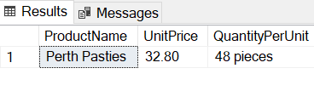

SELECT OrderDate, ShippedDate, CustomerID, Freight

FROM Orders

WHERE OrderDate = '1997-05-19';

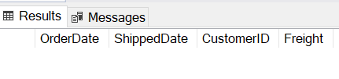

SELECT FirstName, LastName, Country

FROM Employees

WHERE Country <>'USA';

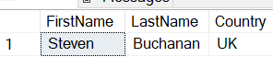

SELECT EmployeeID, OrderID, CustomerID, RequiredDate, ShippedDate

FROM Orders

WHERE ShippedDate > RequiredDate;

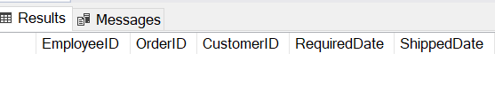

SELECT City, CompanyName, ContactName

FROM Customers

WHERE City LIKE 'A%' OR City LIKE 'B%';

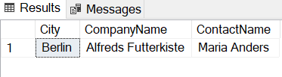

SELECT *

FROM Orders

WHERE Freight > 50;



SELECT ProductName, UnitsInStock, UnitsOnOrder, ReorderLevel

FROM Products

WHERE UnitsInStock <= ReorderLevel;

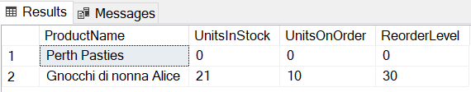

SELECT CompanyName, ContactName, Fax

FROM Customers

WHERE Fax IS NOT NULL;

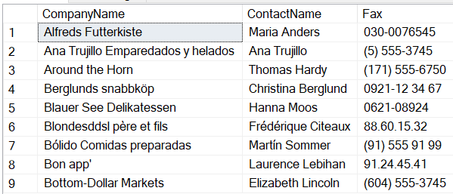

SELECT FirstName, LastName

FROM Employees

WHERE ReportsTo IS NULL;

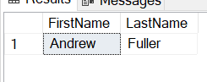

SELECT CompanyName, ContactName, Fax

FROM Customers

WHERE Fax IS NOT NULL

ORDER BY CompanyName;

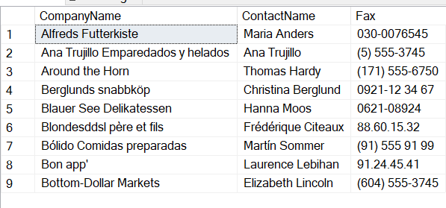

SELECT City, CompanyName, ContactName

FROM Customers

WHERE City LIKE 'A%' OR City LIKE 'B%'

ORDER BY ContactName DESC;



SELECT FirstName, LastName, BirthDate

FROM Employees

WHERE BirthDate BETWEEN '1950-01-01' AND '1959-12-31';

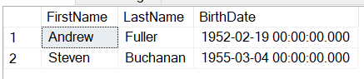

SELECT ProductName, SupplierID

FROM Products

WHERE SupplierID IN (

SELECT SupplierID

FROM Suppliers

WHERE CompanyName IN ('Exotic Liquids', 'Grandma Kelly''s Homestead', 'Tokyo Traders')

);

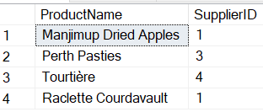

SELECT ShipPostalCode, OrderID, OrderDate

FROM Orders

WHERE ShipPostalCode LIKE '6900%';



SELECT ContactName, ContactTitle, CompanyName

FROM Customers

WHERE ContactTitle NOT LIKE '%Sales%';

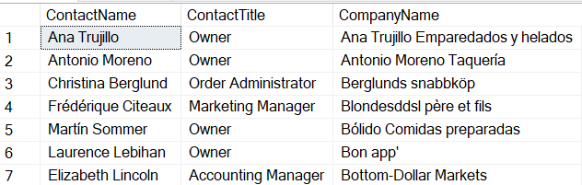

SELECT FirstName, LastName, City

FROM Employees

WHERE City <> 'Seattle';

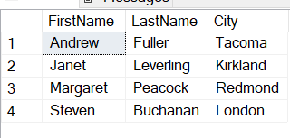

SELECT CompanyName, ContactTitle, City, Country

FROM Customers

WHERE Country = 'Mexico'

OR (Country = 'Spain' AND City <> 'Madrid');

